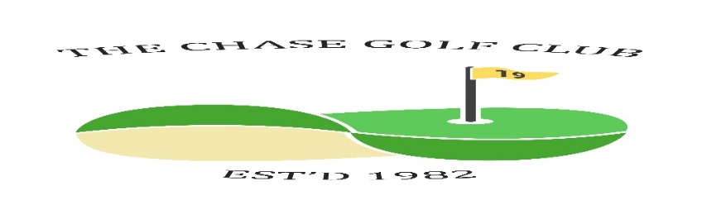
The Chase Golf Club

Competition Draw Sheet Davy Weir Cup
Dates: Wed May 1st Fri 3rd Sat 4th Sun 5th Venue Belleisle
Time &  initials | Wednesday Draw
 | J Brodie | S Smith | S Hannah
 | J Burnett | D Edgar | G Cavanagh | S Kelly
Time &  initials | Friday Draw
 | H Mackie
After 4PM | R McCubbin | D Beattie | I Speirs | S Cassidy
Time &  initials | Saturday Draw
 | T Bloor | R Greenwood | S Kirk | M Mancini
Time &  initials | Sunday Draw
 | E Borland | W Rae | A Muir
 | J Taylor | J Cathcart | R Gilchrist | I Gray
Now the draw has been made you are not able to change days without express consent from a Committee member under the permitted playing conditions. Failure to contact a Committee member will lead to disqualification.
Format | 18 holes white or yellow tee | Handicaps | Strokeplay  Max 28 | Prizes | More than 10 players 1/2/3  Less than 10 players 1/2  Less than 5 is winner only
N.B. If you withdraw from a game, then you must contact all players in your group to let them know. Failure to do so will result in players left without a game and the Committee will take action against offender(s).

